WORK DONE SO FAR - Technical notes of AML-Scan Tool Structure

First Step: define regulatAPIParams

Add properties in InputEvents of formKeys (views.schema.json)

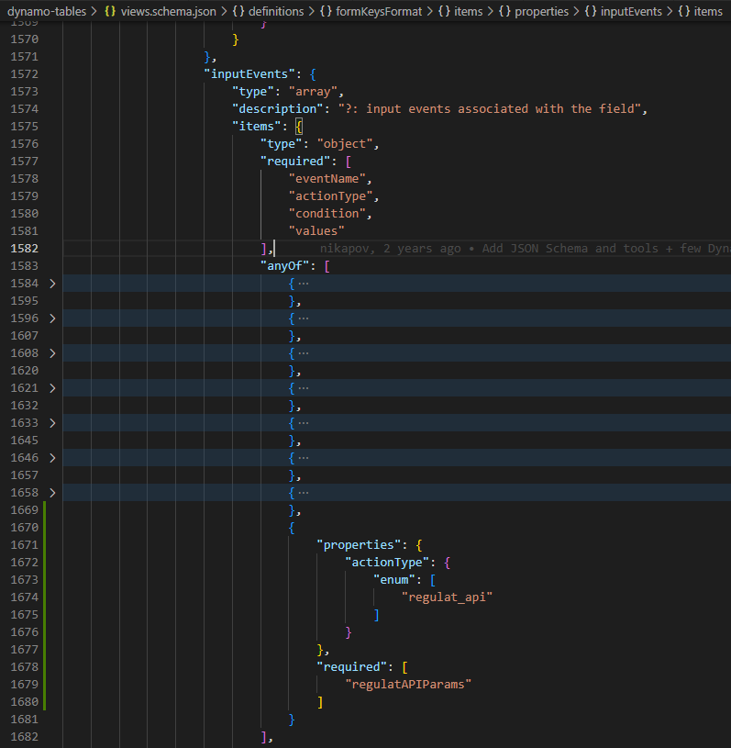

Add regulatAPIParams (views.schema.json)

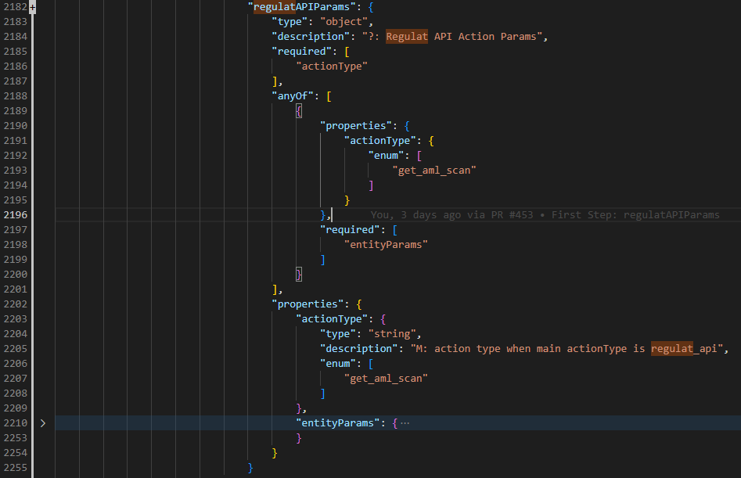

Define entityParams under regulatAPIParams (views.schema.json)

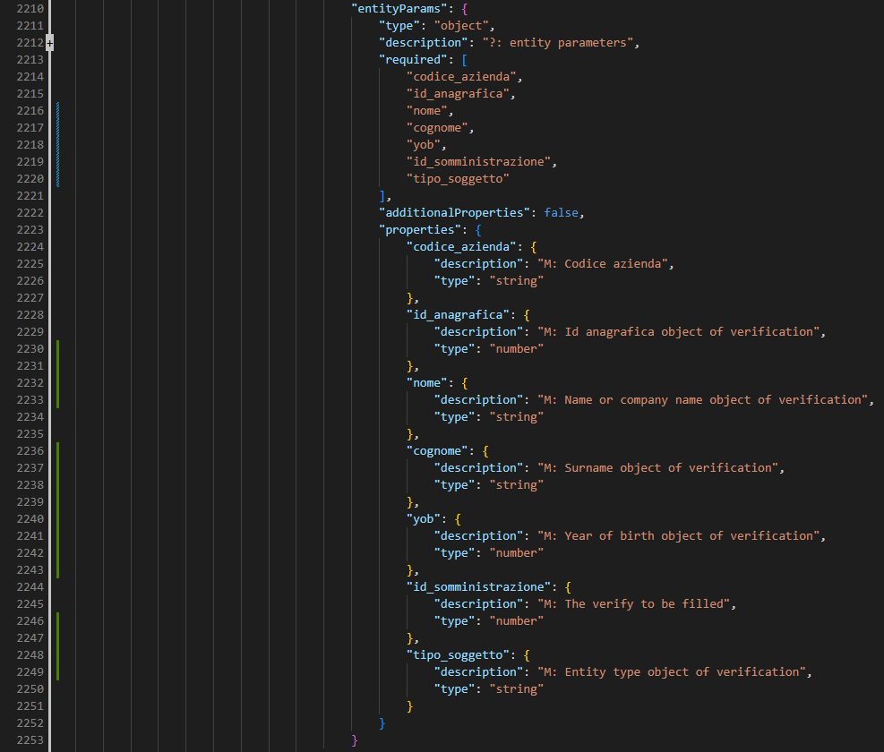

Create interface regulat_api_params.ts

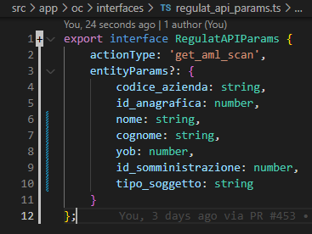

Add export path

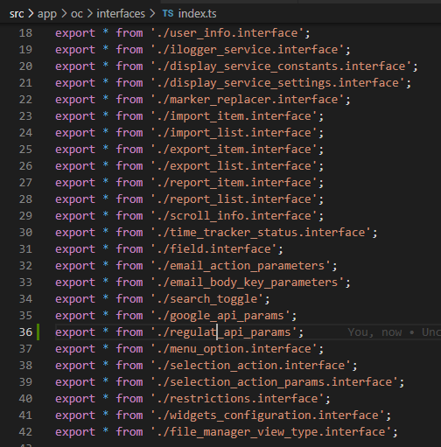

Add in fieldInputEvent in field.interface.ts

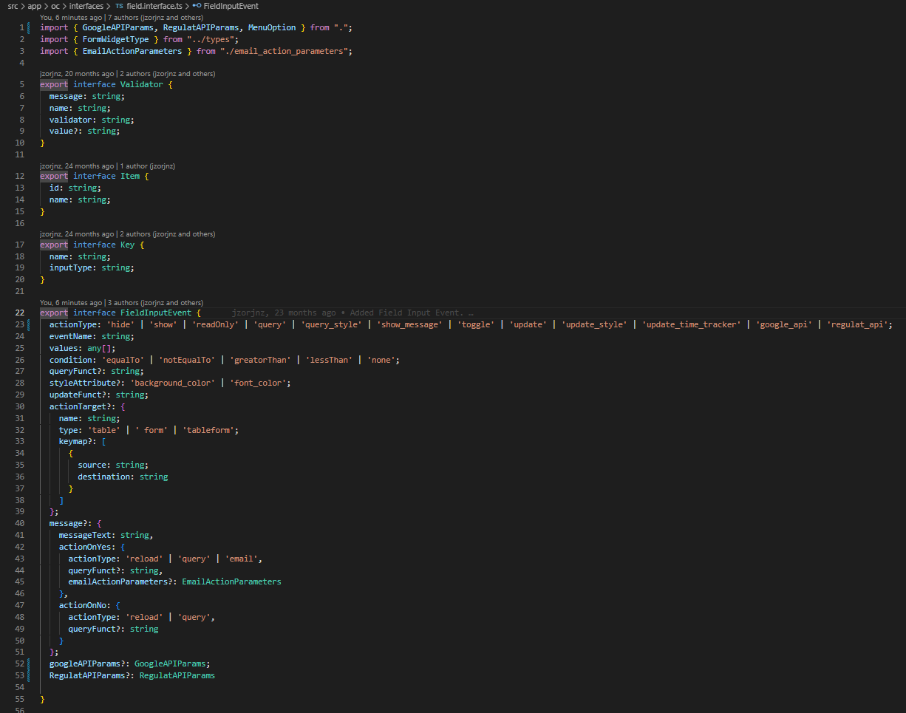

NB: After the 6 points I get this:
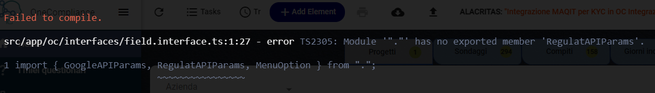
ERROR: Module ‘“.”’ has no exported member ‘RegulatAPIParams’.
/* So for now I commented it, to make the test work. The file where I commented some code are: 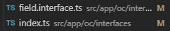
The commit has been named “Commented import interface”.
*/

Second Step: manage the flow in the backend

Add event in form-getter.component.ts (line 1381) which calls runRegulatEvent.

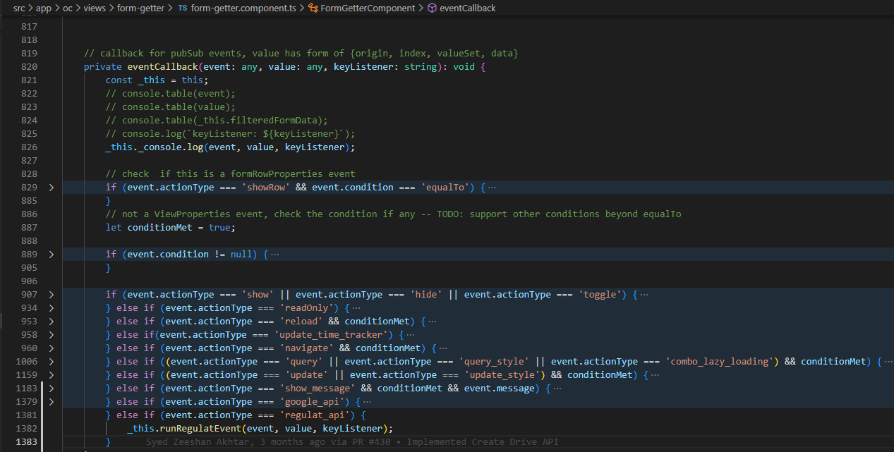

Create async function (first draft) related to the button in form-getter

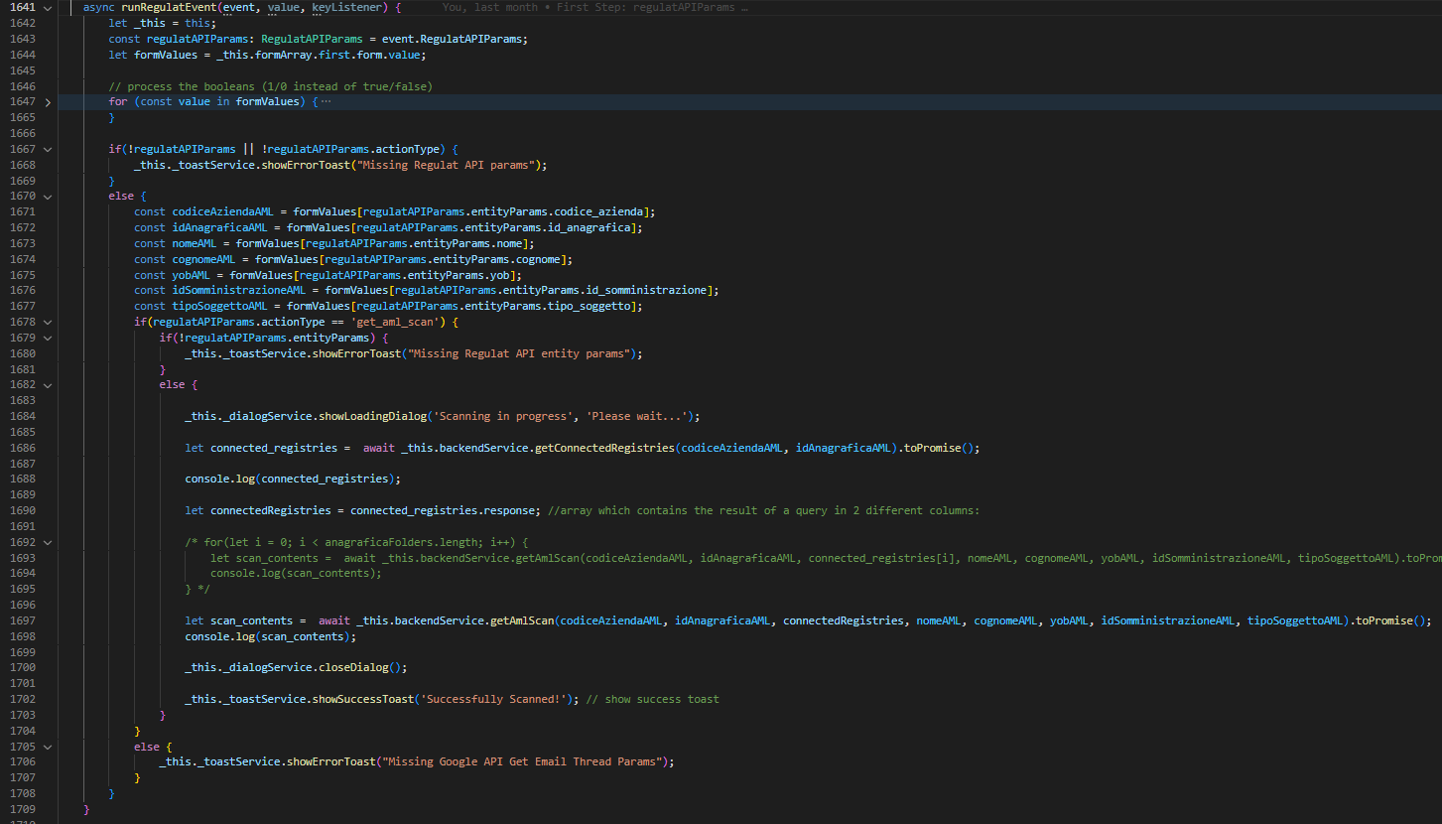
Is it the best way to do it? I have to loop here or in the lambda?

Created the methods in backend.service.ts

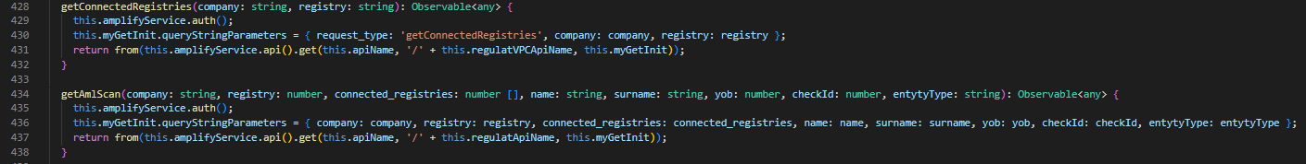

Third Step: Create lambda functs (regulat and regulat_VPC)

Index.js of regulat
Here I do the operation to get the scan result in json format, and when the process is complete the lambda regulat_VPC will be called. Flow: Get acces token (bearer), define which api have to be called (depends on entityType) and get scan result. Then, if the connectedRegistries isn’t void, loop all of element of the array and do another scan. The scan results have to be store in scannedData.
https://github.com/alacritascompliance/onecompliance/blob/c82990932b1fc9534f6079dc96f2db0631540b91/lambda/regulat
NB: I need to pass also the const “company”, “registry” and “checkId” of the “original” registry with the scannedData in the payload of lambda.invoke(regulat_VPC). I nedd to add also the requestType=’getAmlScan’ in the payload.

Index.js of regulat_VPC
From here basically I run this query, passing the calling payload by regulat.lambda
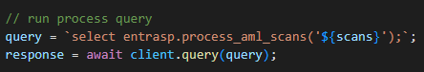

Fourth Step: Database

Table aml_scans on imports schema
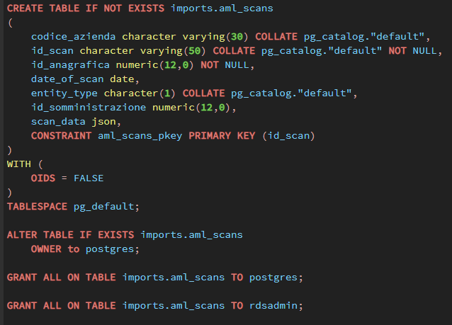
Where in the “scan” attribute I put the response “data” in json format.

entrasp.process_aml_scans(scans json) function
Insert into entrasp.aml_scans the scan result. Then loop for each new scan and insert into risposte.

